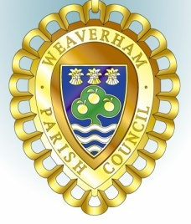
Minutes of the
PLANNING COMMITTEE MEETING

held at Weaverham Community Centre Russet Road Weaverham CW8 3HY
on
Friday 15th November 2024 at 9.15am

Clerk: John Freeman and Peter Wilkinson (Acting Joint Clerks)
Email: clerk@weaverhampc.co.uk
Tel: 01606 854451

P60. Public Open Forum No matters were raised
P61. Present: Cllrs J Freeman, I Mills, R Moss and P Wilkinson plus two members of the public. Absent Cllr G Edwards
No Apologies for Absence were received.
P62. No new interests declared
P63. The minutes of the meeting held on 18th October 2024 were approved.
P64. Recent decisions: The following recent decisions were noted:
24/02632/FUL - 3 Hall View Close Weaverham - Erection of rear conservatory single storey extension. Approved
23/03328/FUL – Land at former Hospital Car Park off Hefferston Rise, Weaverham - Change of use of the old Hefferston hospital car park to a monitoring dog training (sports) field and erection of a stable building for storage of training and maintenance equipment and tack room - Partly retrospective. Withdrawn
P65. 24/03125/FUL - 39 Hawthorn Road Weaverham - Two storey and part single storey side extension. No objections provided that sufficient on-site parking remains to comply with planning policy.
P66. Date of next meeting: Friday, 29th November 2024 at 9:15am was confirmed.

Agreed and approved: _______________________

Date: ___________________________

