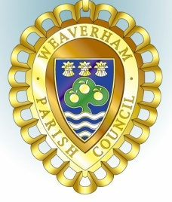
Councillors are summoned to attend the
WEAVERHAM PLANNING COMMITTEE MEETING

To be held at Weaverham Community Centre, Russet Road, Weaverham CW8 3HY
on
Friday, 18th October 2024 at 9:15am

Clerk: John Freeman and Peter Wilkinson (Acting Joint Clerks)
Email: clerk@weaverhampc.co.uk
Tel: 01606 854451
14th October 2024
AGENDA

P52. Public Open Forum
Members of the public are invited to address Councillors and raise issues of concern. This session will last no longer than 10 minutes.
P53. To welcome and register attendees and approve any apologies for absence.
P54. To receive any declarations of new interest.

P55. To approve the Minutes of the meeting held on 4th October 2024
P56. To note the following recent decision:
24/02130/FUL - 25 High Street Weaverham - Single storey garden shed - Approved
P57. 24/02868/FUL - 14 Forster Avenue Weaverham - Rear extension
P58. 24/02824/CAT - 52 High Street Weaverham - 1 x Silver Birch - Request to crown reduce by 1.5m to previous to keep healthy shape. 1 x Silver Birch - Request to fell to ground level due to complaints from neighbours and pushing fence.
P59. Date of next meeting: Friday, 1st November 2024 at 9:15am
Signed:

Peter Wilkinson,
Joint Acting Clerk

