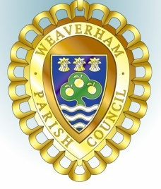
Minutes of the
PLANNING COMMITTEE MEETING

held at Weaverham Community Centre Russet Road Weaverham CW8 3HY
on
Friday 14th June 2024 at 9.15am

Clerk: John Freeman and Peter Wilkinson (Acting Joint Clerks)
Email: clerk@weaverhampc.co.uk
Tel: 01606 854451

P8. Public Open Forum No matters were raised.
P9. Present: Cllrs J Freeman, I Mills and R Moss Apologies for Absence were received from Cllr P Wilkinson and approved. Absent Cllr G Edwards
P10. No new declarations of interest were made.
P11. The minutes of the meeting held on 31st May 2024 were approved.
P12. Recent decisions: None received.
P13. 24/01577/TPO - 46A High Street Weaverham - Dead Birch (T1) - Fell to ground level. No objections
P14. Date of next meeting: Friday, 28th June 2024 at 9:15am was confirmed.

Agreed and approved: _______________________

Date: _________________________

