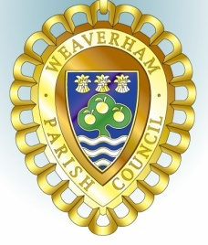
Councillors are summoned to attend the
WEAVERHAM PLANNING COMMITTEE MEETING

To be held at Weaverham Community Centre, Russet Road, Weaverham CW8 3HY
on
Friday, 26th July 2024 at 9:15am

Clerk: John Freeman and Peter Wilkinson (Acting Joint Clerks)
Email: clerk@weaverhampc.co.uk
Tel: 01606 854451
22nd July 2024
AGENDA

P24. Public Open Forum
Members of the public are invited to address Councillors and raise issues of concern. This session will last no longer than 10 minutes.
P25. To welcome and register attendees and approve any apologies for absence.
P26. To receive any declarations of new interest.

P27. To approve the Minutes of the meeting held on 12th July 2024

P28. To note the following recent decisions:
24/01546/PMA – 24 Church Street Weaverham - Conversion of beauty salon to residential accommodation – Decided, Prior Approval not required
24/00843/FUL - 48A High Street Weaverham - Installation of Solar PV panels to south east and north west facing roof faces - Approved

P29. 24/01078/FUL - Gorstage Hall Weaverham Road Weaverham - Erection of a new wooden field gate to existing wooden post and rail fencing
P30. Date of next meeting: Friday, 9th August 2024 at 9:15am
Signed:

Peter Wilkinson,
Joint Acting Clerk

