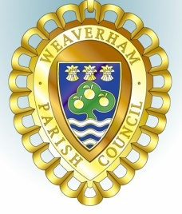
Councillors are summoned to attend the
WEAVERHAM PLANNING COMMITTEE MEETING

To be held at Weaverham Community Centre, Russet Road, Weaverham CW8 3HY
on
Friday, 14th June 2024 at 9:15am

Clerk: John Freeman and Peter Wilkinson (Acting Joint Clerks)
Email: clerk@weaverhampc.co.uk
Tel: 01606 854451
10th June 2024
AGENDA

P10. Public Open Forum
Members of the public are invited to address Councillors and raise issues of concern. This session will last no longer than 10 minutes.
P11. To welcome and register attendees and approve any apologies for absence.
P12. To receive any declarations of new interest.

P13. To approve the Minutes of the meeting held on 31st May 2024

P14. To note the following recent decisions:

P15. 24/01577/TPO - 46A High Street Weaverham - Dead Birch (T1) - Fell to ground level.
P16. Date of next meeting: Friday, 28th June 2024 at 9:15am
Signed:

Peter Wilkinson,
Joint Acting Clerk

