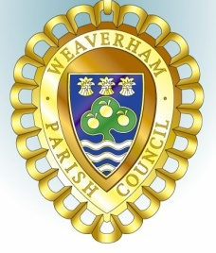
Weaverham Parish Council
Weaverham Community Centre, Russet Road, Weaverham, Northwich, Cheshire, CW8 3HY
Tel: 01606 854451(24hr voicemail) Email: clerk@weaverhampc.co.uk

Councillors are summoned to attend the
Environment Committee Meeting
To be held at
Weaverham Community Centre, Russet Road, Weaverham, CW8 3HY

on Wednesday 10th July 2024 at 7:15pm.
5th July 2024
AGENDA
Members of the public are reminded that they are only allowed to speak when invited to do so by the Chairman.

E1. Public Open Forum: Members of the public are invited to address Councillors and table issues of concern. This session will last no longer than 10 minutes, individuals may only speak once and for a maximum of three minutes.
E2. To elect Chairman for 2024/25
E3. To elect Vice Chairman for 2024/25
E4. Welcome & Register of Attendees and to approve any apologies for absence.
E5. To receive any new declarations of Interest.
E6. To approve the minutes of the meeting held on 10th April 2024.
E7. To receive an update about plans to install a café/snack bar/toilet near the Play Park. (IL)
E8. To receive an update regarding re-development of the former Youth Club premises (PW & IL)
E8.1 To recommend approval for Dane Architecture to proceed with preparing more detailed plans for the proposed building.
E8.2 To recommend approval of quote to clear front and rear of former Youth Club premises ((£450 + VAT)
E9. To approve draft letter to be sent to occupiers following overgrown hedge complaints
E10. To recommend approval of quote to provide and install additional litter bin at the Play Park (£400 + VAT)
E11 To recommend approval of quote for restoration of bonfire site on Lake House Field (£1600 + VAT)
E12. To recommend approval of quote to install lockable bollards at entrance to Old Doctors’ Surgery car park (560 + VAT)
E11. To confirm date of next meeting – Wednesday, 11th September at 7:15pm

Peter Wilkinson,
Joint Acting Clerk.

