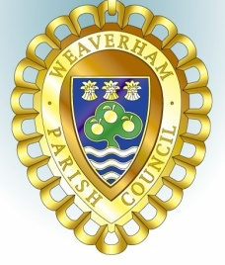
Minutes of the
PLANNING COMMITTEE MEETING

held at Weaverham Community Centre Russet Road Weaverham CW8 3HY
on
Friday 5th April 2024 at 9.15am

Clerk: John Freeman and Peter Wilkinson (Acting Joint Clerks)
Email: clerk@weaverhampc.co.uk
Tel: 01606 854451

P122. Public Open Forum No matters were raised
P123. Present: Cllrs J Freeman, I Mills, R Moss and P Wilkinson plus 2 members of the public
P124. No new declarations of interest were made.
P125. Minutes: The minutes of the meeting held on 15th March 2024 were approved.
P126. Recent decisions: The following recent decision was noted.
23/02738/FUL - 1 The Stables Hefferston Hall Weaverham - Proposed replacement of external doors to main house. New external hot water tap. Refurbishment of En-Suite. Proposed alterations to driveway. Approved

P127. 24/00520/FUL – 5 Brookside Weaverham – Single story rear extension, garage conversion and associated alterations. Object as the proposal contravenes guidance regarding off-road parking spaces
P128. 24/00632/FUL & 24/00633/LBC – 1 The Stables Hefferston Hall Weaverham – Erection of detached garage, alterations to driveway. No objections
P129. 24/00614/FUL – Hartford Golf Club Wallerscote Road Hartford – Alterations to existing driving range safety fencing, extension to existing car park and the provision of 4 padel courts. No objection subject to lights not creating issues for drivers on adjacent highways.
P121. Date of next meeting: Friday, 19th April 2024 at 9:15am was confirmed.

Agreed and approved: _______________________

Date: _________________________

