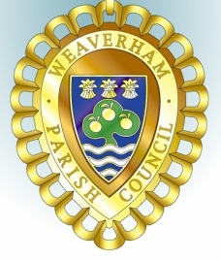
MINUTES OF THE YOUTH COMMITTEE MEETING
Held at
Weaverham Community Centre, Russet Road, Weaverham, CW8 3HY
on
Wednesday 6th October 2021 at 7.15pm
Acting Clerks P Wilkinson and J Freeman
Email: clerk@weaverhampc.co.uk
Tel: 01606 854451

Present: Cllrs G Williams (chairman), P Wilkinson and J Freeman

Y10. Public Forum – No members of the public present.

Y11. Apologies – Cllrs M Gerrard and A Morgan

Y12. Declarations of interest – none

Y13. Minutes of the meeting held on 21st July 2021 were approved and signed.

Y14. It was agreed to recommend to Council that Christmas Support for vulnerable young people be provided again this year with expenditure to a maximum of £700 to be taken from the Youth budget.
Y15. It was agreed that Cllr Williams would discuss with the Youth Worker the best way forward to provide access to the MUGA facility for young people of the village.

Y16. It was confirmed that the next meeting will be held on Wednesday,8th December 2021 at 7:15pm.

Meeting closed at 7:43pm.

