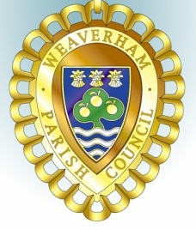
MINUTES OF THE YOUTH COMMITTEE MEETING
Held at
Weaverham Community Centre, Russet Road, Weaverham, CW8 3HY
on
Wednesday 21st July 2021 at 7.15pm
Acting Clerks P Wilkinson and J Freeman
Email: clerk@weaverhampc.co.uk
Tel: 01606 854451

Present: Cllrs G Williams (chairman), P Wilkinson and J Freeman

Y9. Public Forum – No members of the public present.

Y10. Apologies – none

Y11. Declarations of interest – none

Y12. Minutes of the meeting held on 16th June 2021 were approved and signed.

Y13. Working Group Report
Report received. To develop some of the suggestions in the report needs some volunteer to help to organise various activities. Initially it is proposed to purchase 2 netballs and 4 tennis racquets and to publicise the availability of the MUGA. Will look to clear out the shed and improve storage by providing some shelving.

Y14. Meeting dates – 6th October, 8th December, 23rd February and 20th April.

Meeting closed at 7:52pm.

